 Odessey

**Home Destination Packages Contact Book Now**

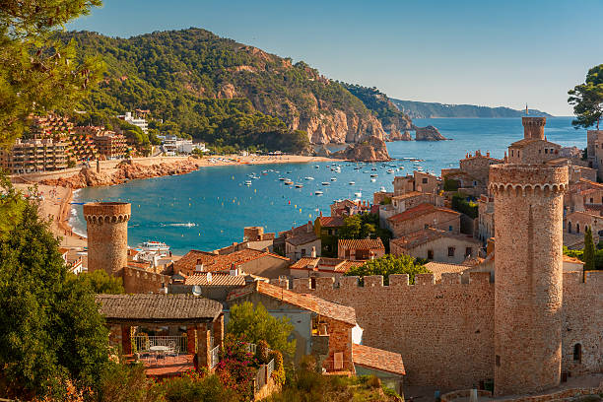

Discover the beauty of the world's diverse landscapes and cultures with Odyssey by your side

From ancient wonders to modern marvels, Odyssey curate's unforgettable journeys tailored to your desires. Explore picturesque landscapes, immerse yourself in vibrant cultures, and create memories that last a lifetime. Let us guide you on a transforming voyage where every destination becomes an adventure, and every moment is filled with wonder.

**Popular Destinations**

Discover a world of wonders with Odyssey Travels. Our curated selection of destinations invites you to explore diverse landscapes, vibrant cultures, and unforgettable experiences. Whether you're drawn to historic landmarks, natural beauty, or bustling cities, our destinations offer something for every traveler. Let us be your guide on a journey of discovery and adventure

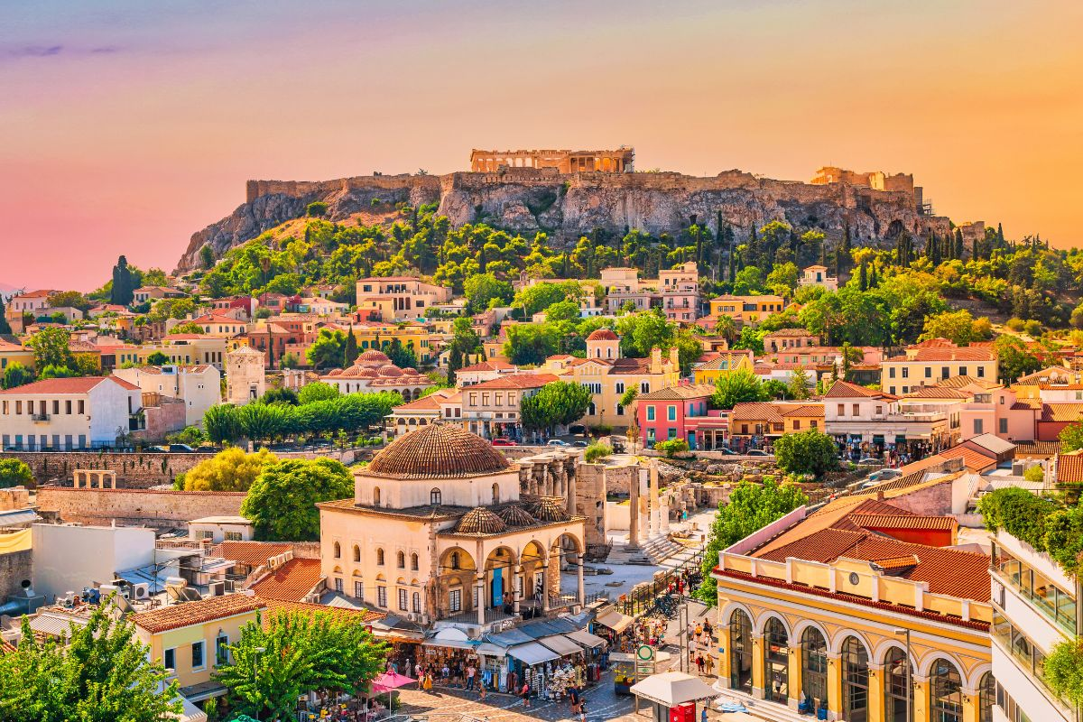

rating = 4.7

**Athens, Greece**

Immerse yourself in the vibrant atmosphere of Placa, with its charming tavernas, bustling markets, and lively bougainvillea-lined alleyways.

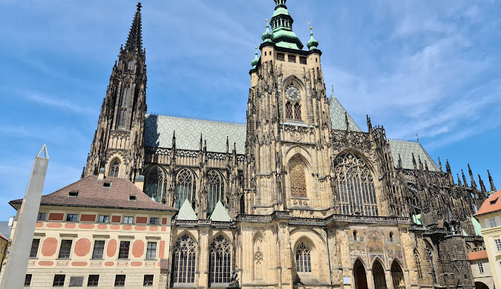

rating = 4.8

**Prague, Czech Republic**

Lose yourself in the fairy-tale charm of Prague, where Gothic spires, Baroque architecture, and medieval cobblestone streets create an enchanting backdrop for exploration

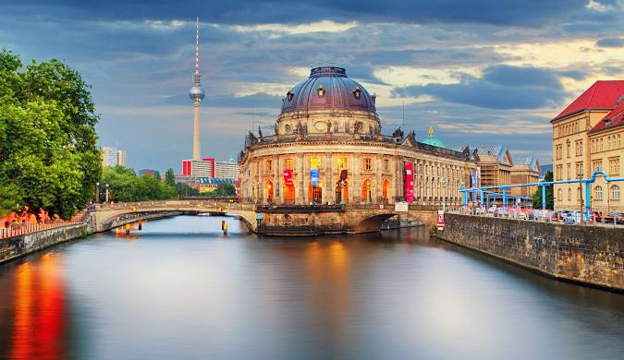

star rating = 4.7

**Berlin, Germany**

Dive into the city's eclectic cultural scene, with world-class museums, avant-garde galleries, and cutting-edge nightlife venues offering something for every taste and interest.

**More details**

**Featured Packages**

Explore our carefully crafted travel packages, designed to immerse you in the wonders of each destination, from iconic landmarks to hidden gems, creating unforgettable experiences tailored to your preferences."

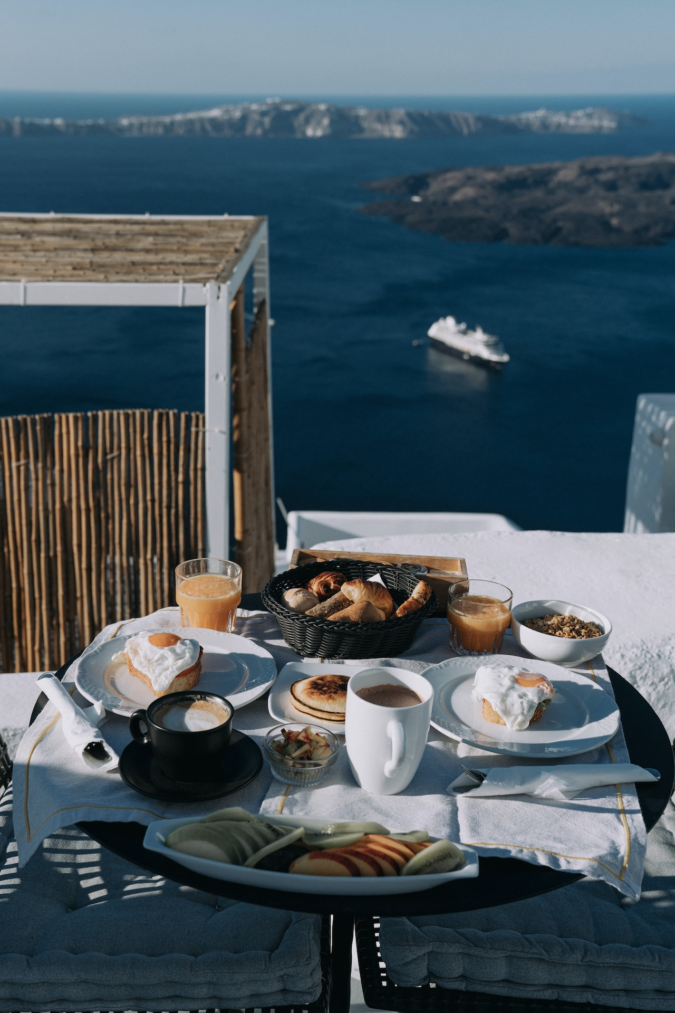

**Athens basic**

rating = 4.7

Price = 1000 euro/person

Athens, Greece

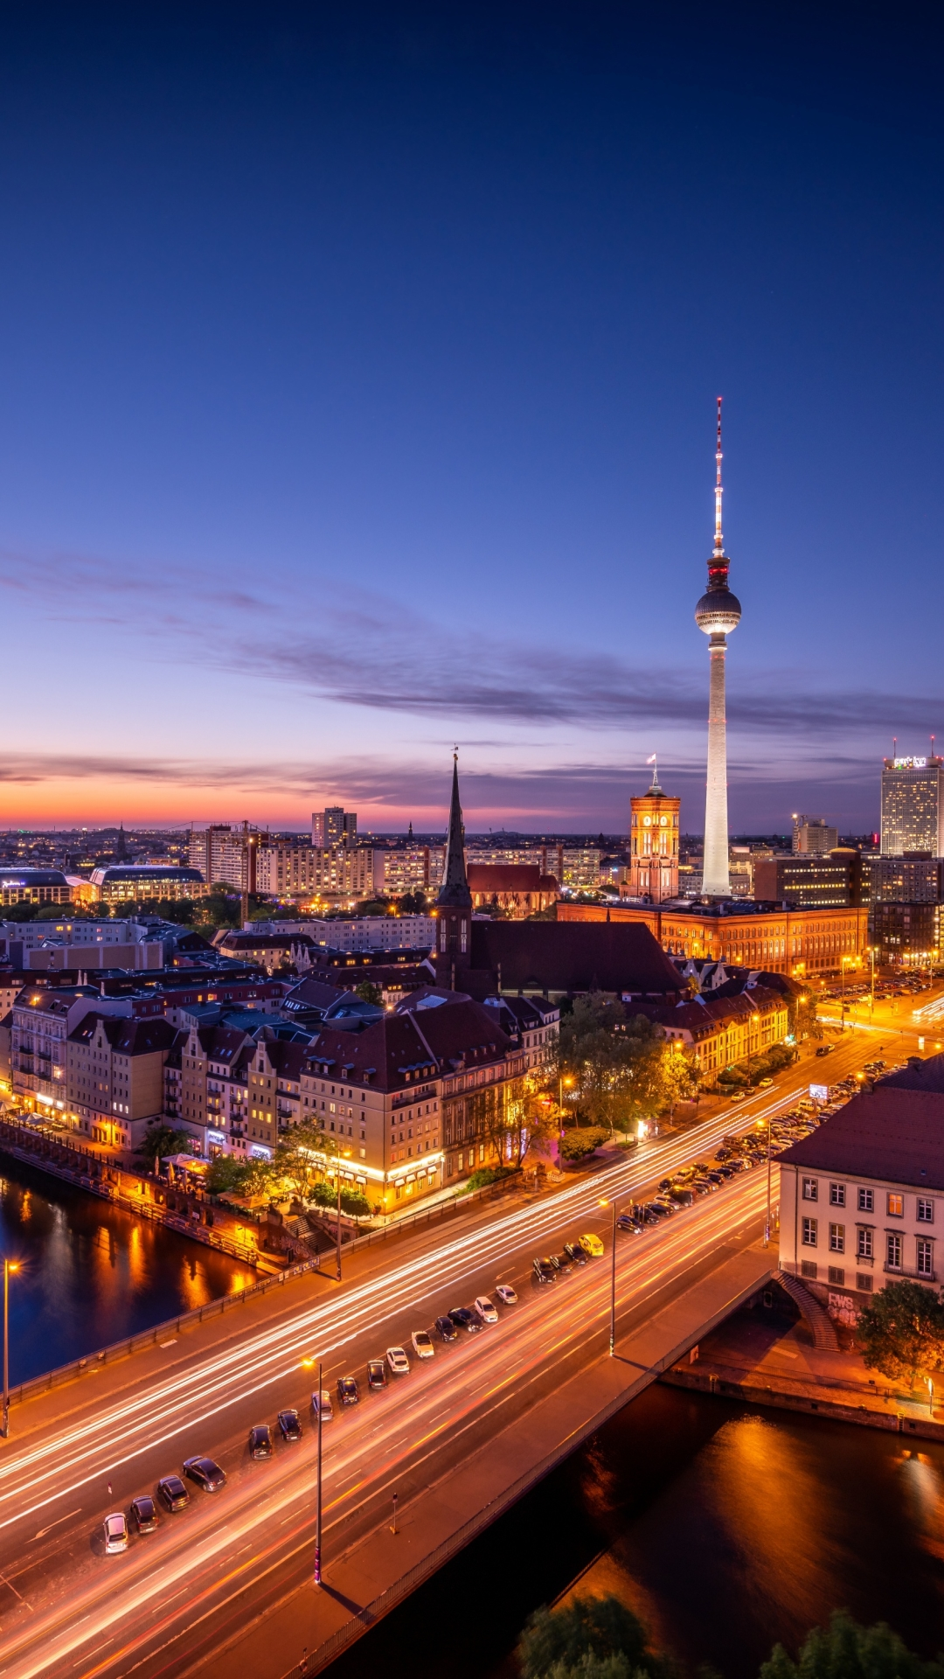

**Berlin premium**

rating = 4.9

Price = 2000 euro / person

Berlin, Germany

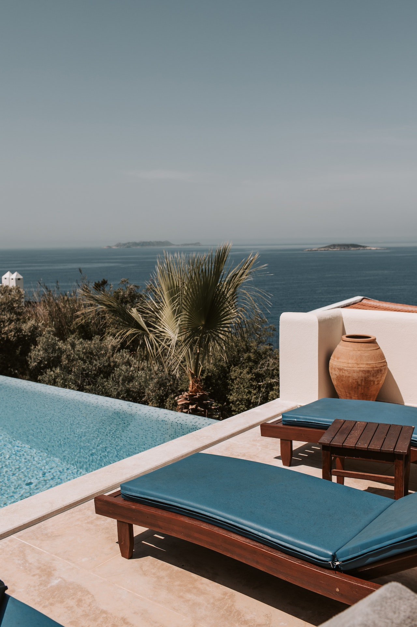

**Prague basic**

rating = 4.8

Price = 1200 euro / person

Prague, Czech Republic

**Details**

**Quick Links**

Home

Destination

Packages

Gallery

Contact

Book Now

**Contacts**

Phone: +36202600881

Email: [mailtoamir17@gmail.com](mailto:mailtoamir17@gmail.com)

Budapest, Attila út 125, 1012

Subscribe to our newsletter

**Odessey**  Amir Abdullah Zakaria All Rights reserved    

 **Odessey**

**Home Destination Packages Contact Book Now**

**Destinations**

Embark on a journey of discovery as you explore our diverse range of destinations. From iconic cities to hidden gems, each destination offers its own unique charm and allure. Whether you're seeking adventure, relaxation, or cultural immersion, our carefully curated selection of destinations promises unforgettable experiences tailored to your preferences

**Athens**

Ancient yet dynamic, Athens beckons with its timeless allure and modern vibrancy. Immerse yourself in the birthplace of democracy, where ancient ruins stand alongside chic cafes and vibrant markets. Explore the Acropolis, where the Parthenon overlooks the city, and wander through historic Placa, where winding streets reveal hidden treasures. Indulge in mouthwatering Greek cuisine, from traditional tavernas to contemporary eateries. With its rich history, stunning landmarks, and bustling energy, Athens promises an unforgettable journey through time and culture.

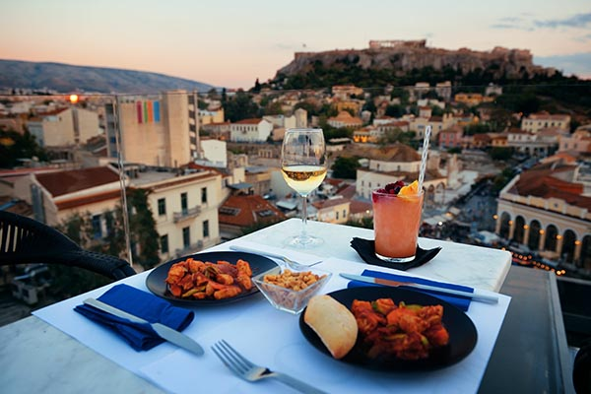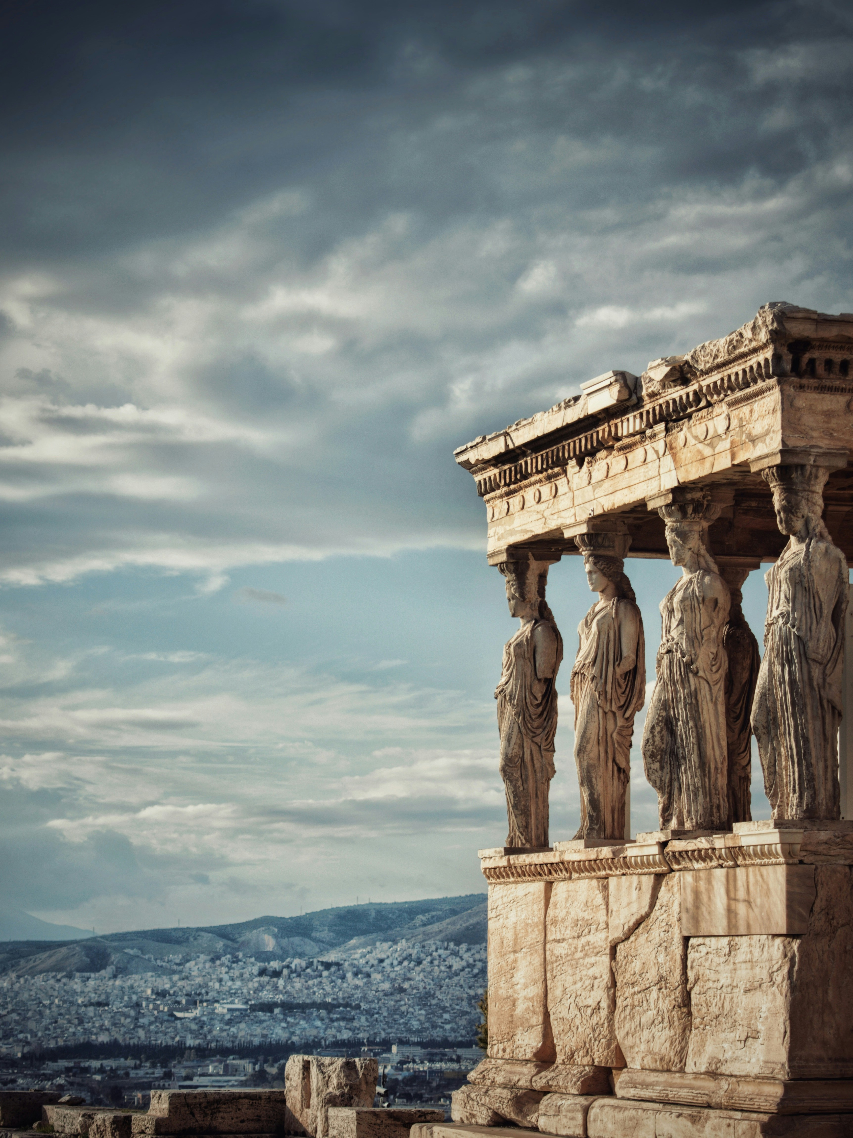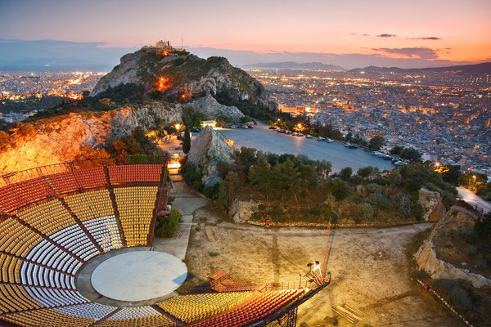

image and videos of Athens

**Prague**

Step into a fairy-tale world in the heart of Europe with a visit to Prague. Lose yourself in the winding cobblestone streets lined with centuries-old architecture, where Gothic spires pierce the skyline and Baroque palaces beckon with their enchanting beauty. Discover the charm of the historic Old Town Square, where the Astronomical Clock comes to life with its hourly show. Indulge in the city's rich cultural scene, from classical concerts in grand concert halls to quirky art installations in hidden courtyards. With its magical ambiance, rich history, and vibrant culture, Prague promises an unforgettable journey through time and beauty

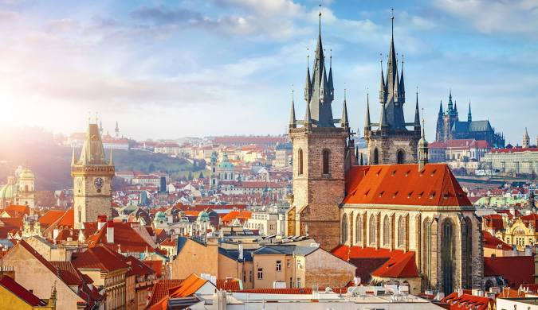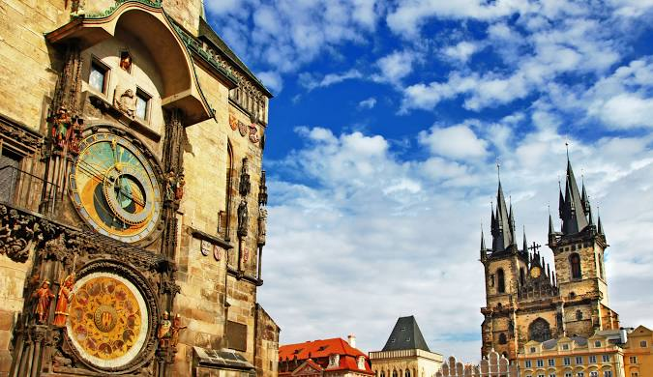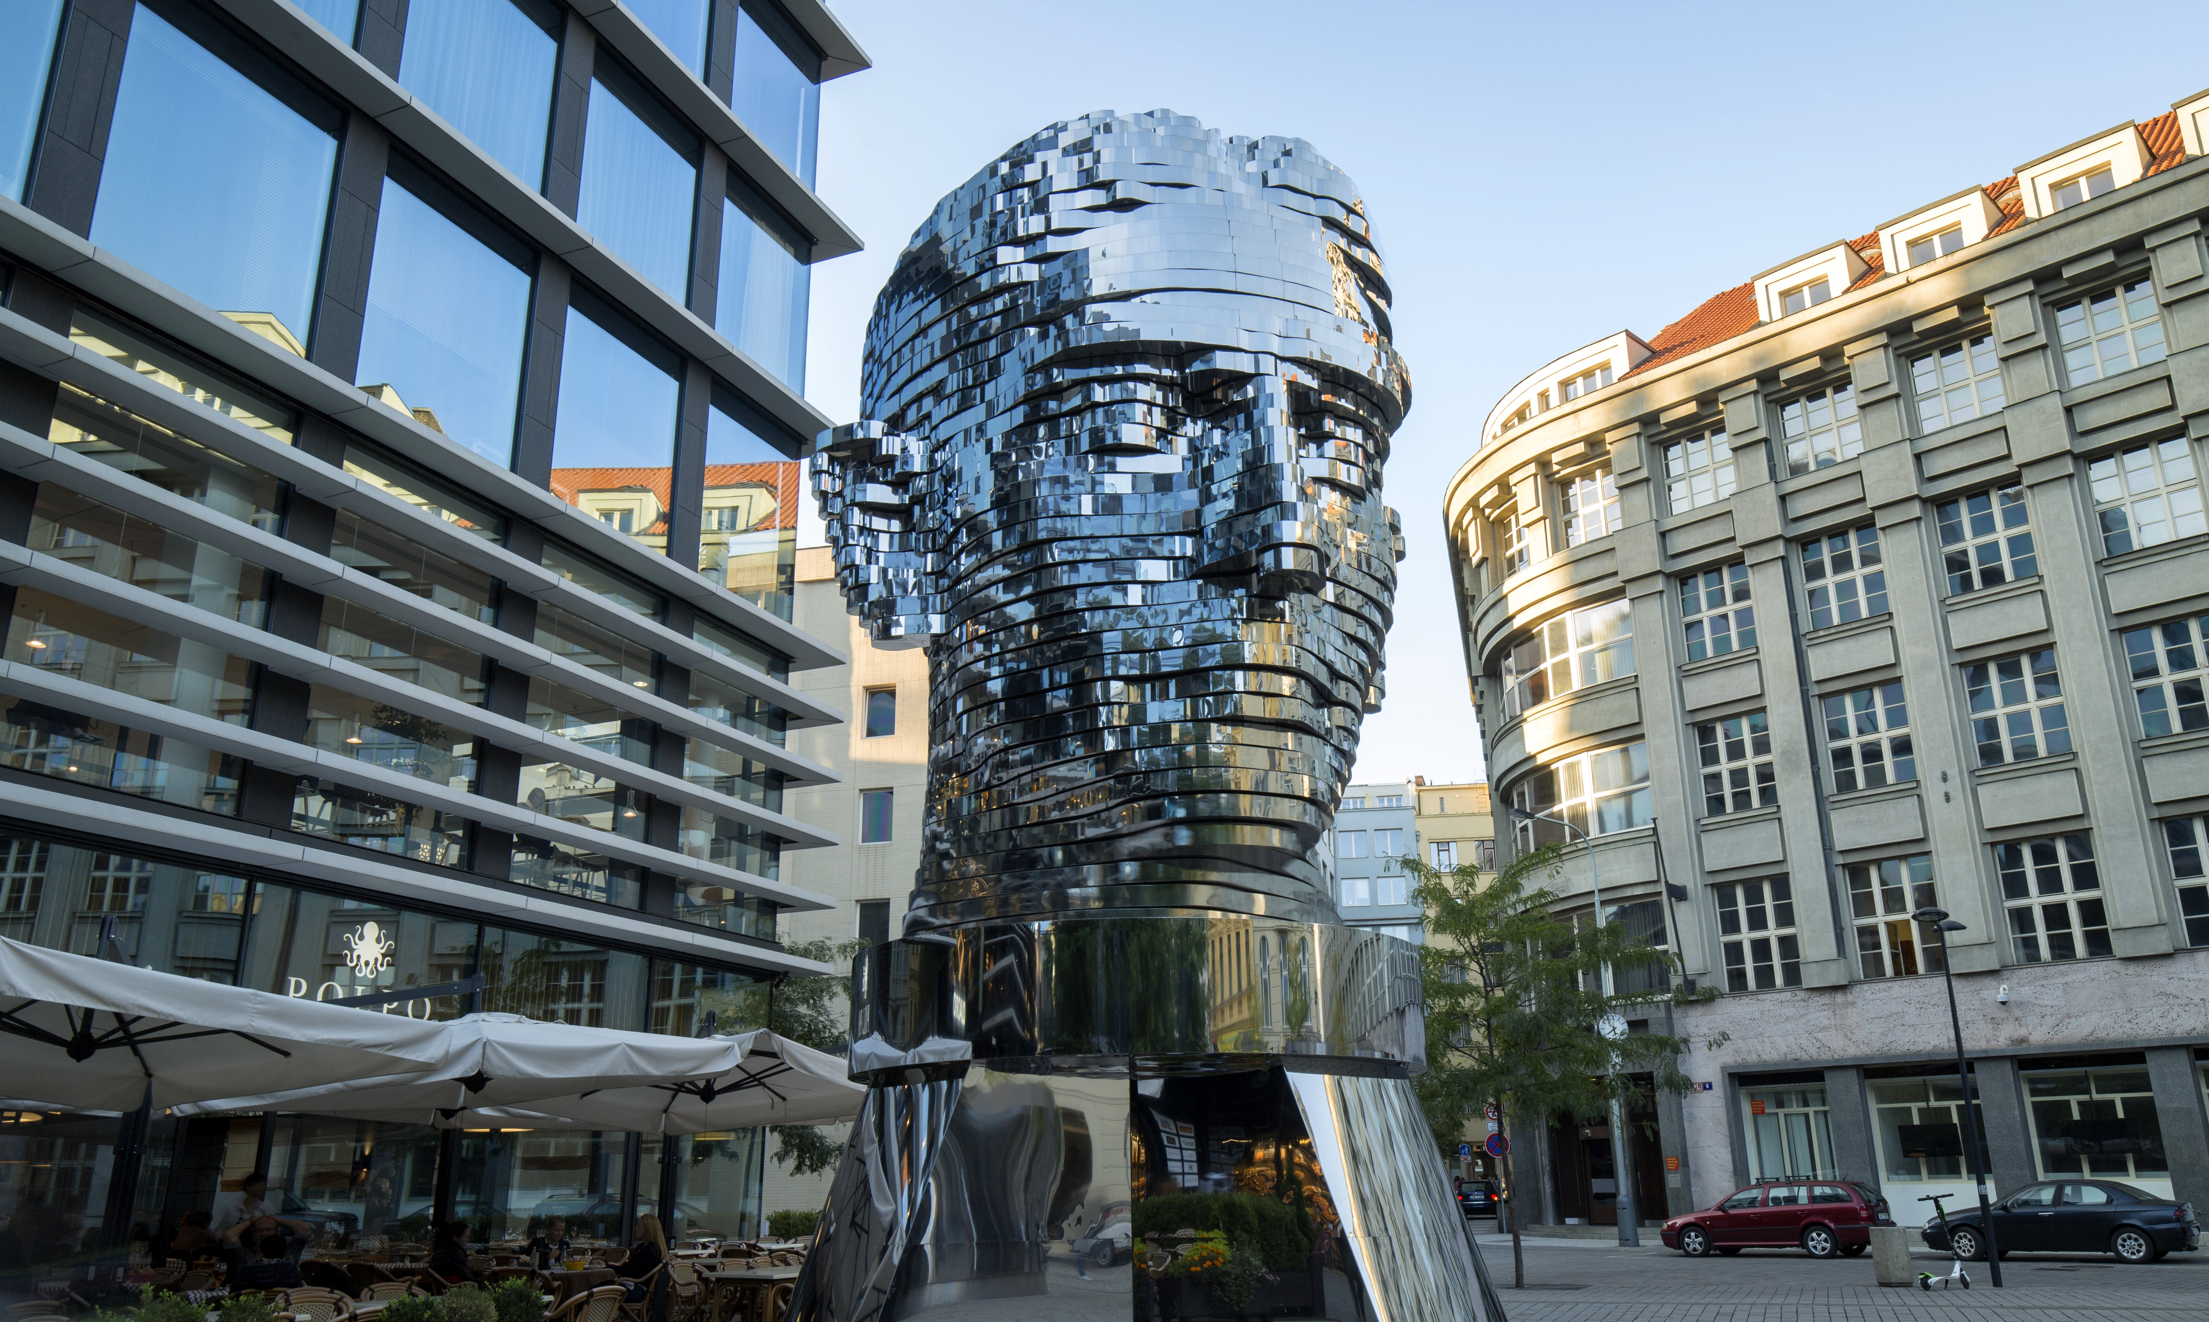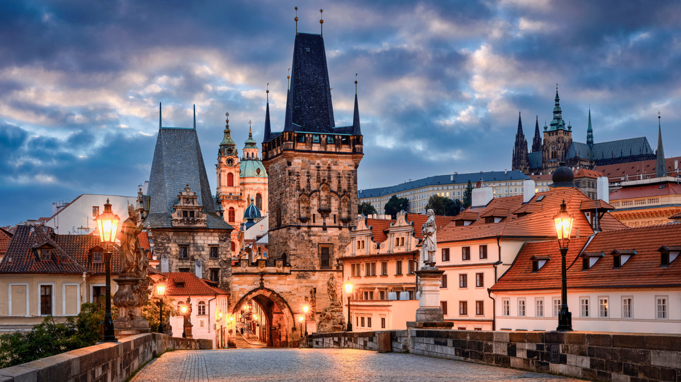

images of the famous places of Prague

**Berlin**

Experience the dynamic pulse of Berlin, where history, culture, and creativity collide to create a vibrant tapestry of experiences. From the iconic Brandenburg Gate to the remnants of the Berlin Wall, every corner tells a story of resilience and reinvention. Immerse yourself in the city's eclectic neighborhoods, where street art adorns the walls and hidden gems await around every corner. Indulge in the city's world-class cuisine, vibrant nightlife, and diverse cultural scene. With its unparalleled energy and endless possibilities, Berlin invites you to explore, discover, and be inspired.

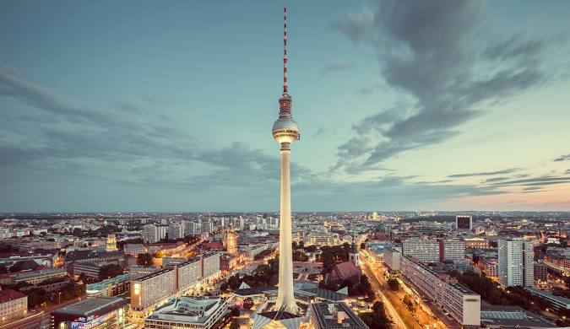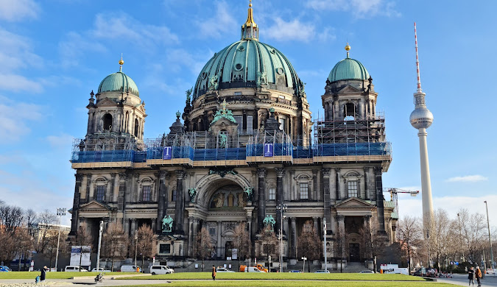

images of top attractions of berlin

**Quick Links**

Home

Destination

Packages

Gallery

Contact

Book Now

**Contacts**

Phone: +36202600881

Email: [mailtoamir17@gmail.com](mailto:mailtoamir17@gmail.com)

Budapest, Attila út 125, 1012

Subscribe to our newsletter

**Odessey**  Amir Abdullah Zakaria All Rights reserved    

 **Odessey**

**Home Destination Packages Contact Book Now**

**Travel Packages**

Discover our curated selection of travel packages designed to cater to every traveler's dream

**Athens Packages**

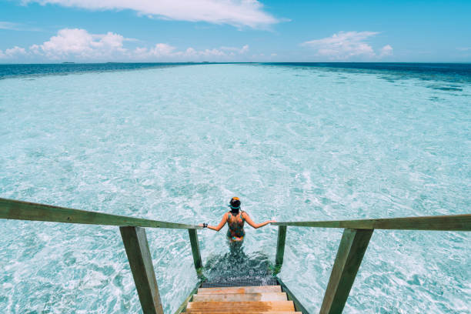

|  |  |  |
| --- | --- | --- |
| Feature | Basic Package | Premium Package |
| Hotel | 5-star | 5-star |
| Stay Duration | 7 days/nights | 10days/nights |
| Meals | Breakfast | Breakfast, Snacks |
| Tour Guide | No | Yes |
| Customer Service | 24/7 | 24/7 |
| Total Cost | €1000 | €1500 |

**Prague Packages**

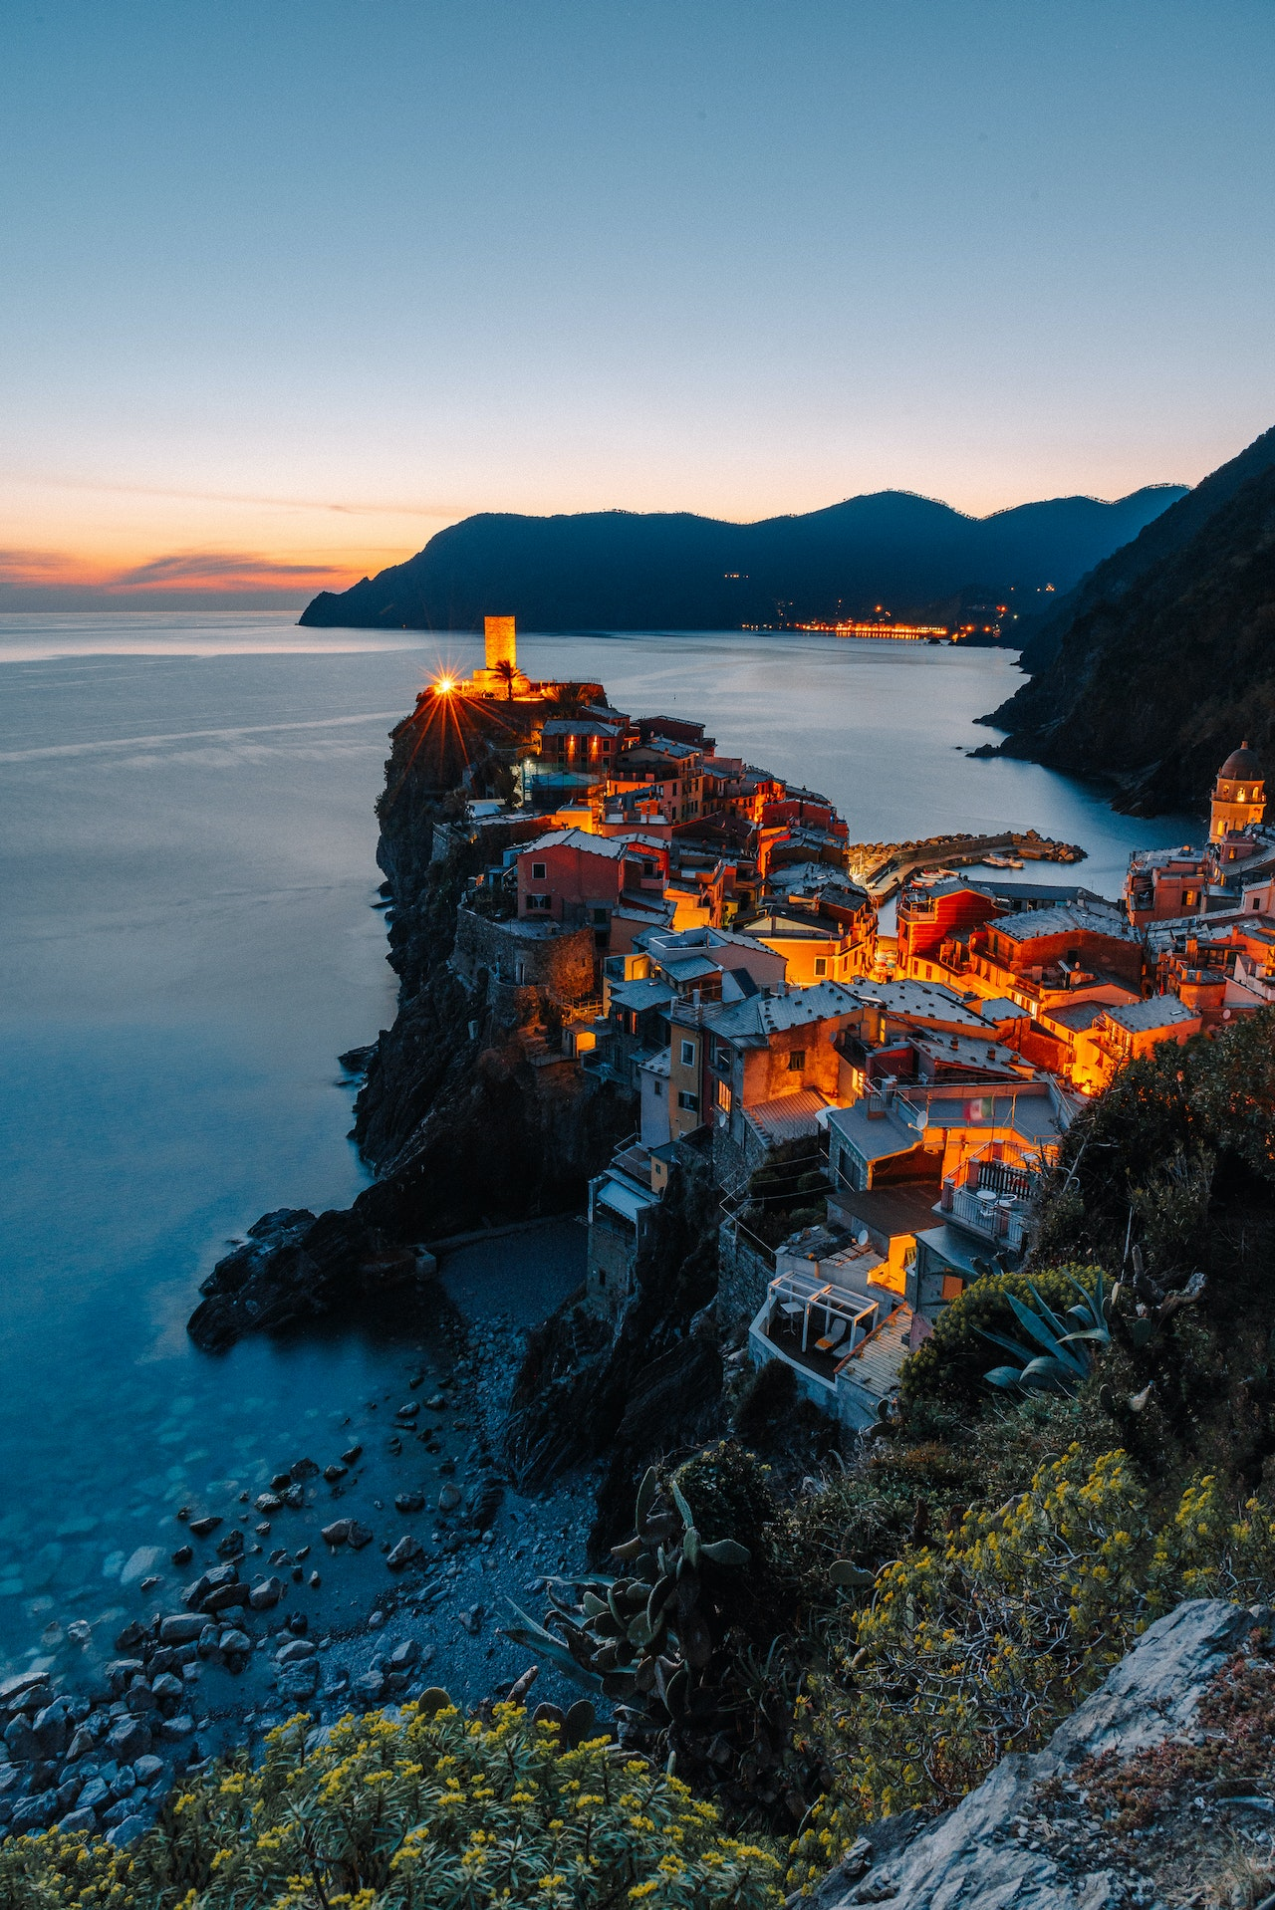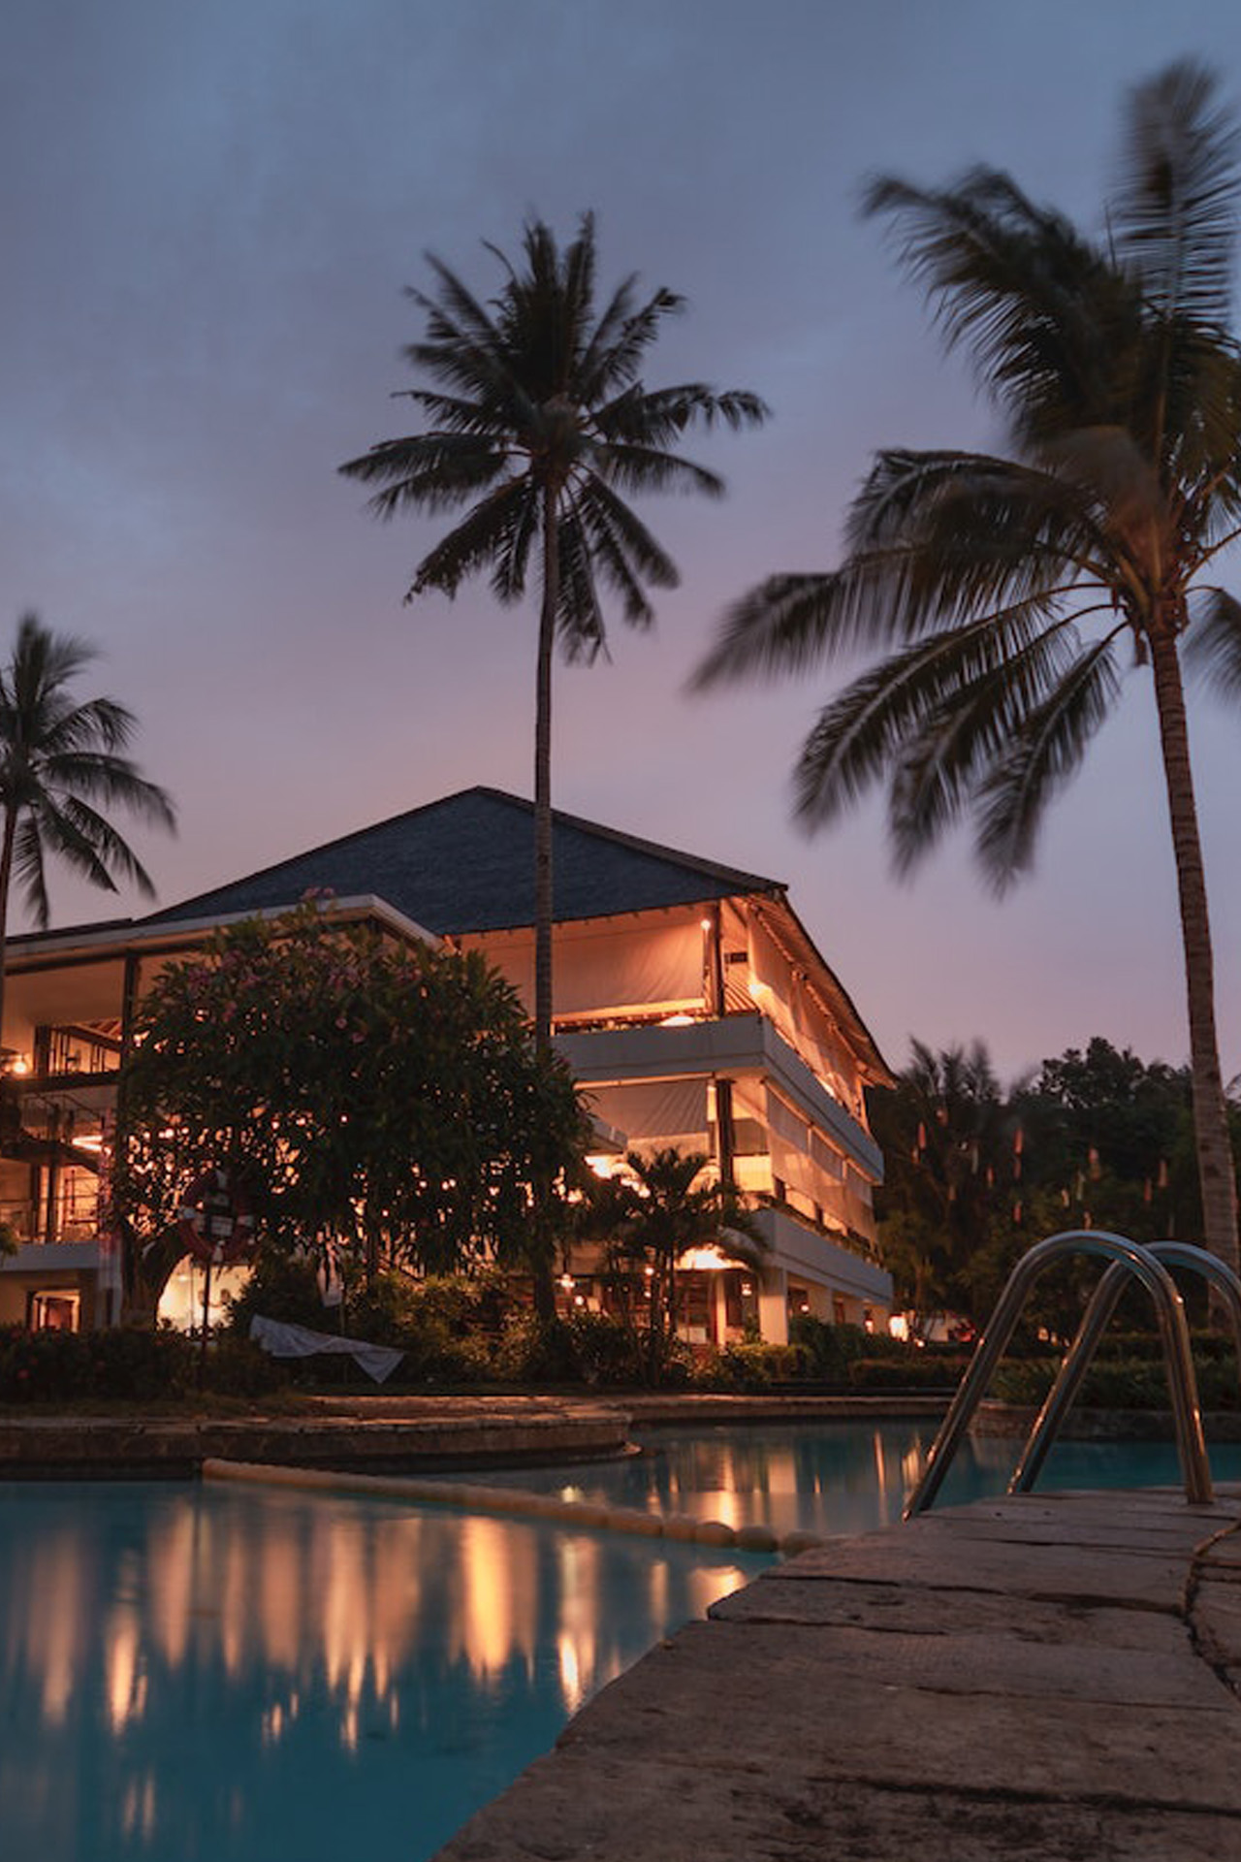

|  |  |  |
| --- | --- | --- |
| Feature | Basic Package | Premium Package |
| Hotel | 5-star | 5-star |
| Stay Duration | 7 days/nights | 10days/nights |
| Meals | Breakfast | Breakfast, Snacks |
| Tour Guide | No | Yes |
| Customer Service | 24/7 | 24/7 |
| Total Cost | €1200 | €1700 |

**Berlin Packages**

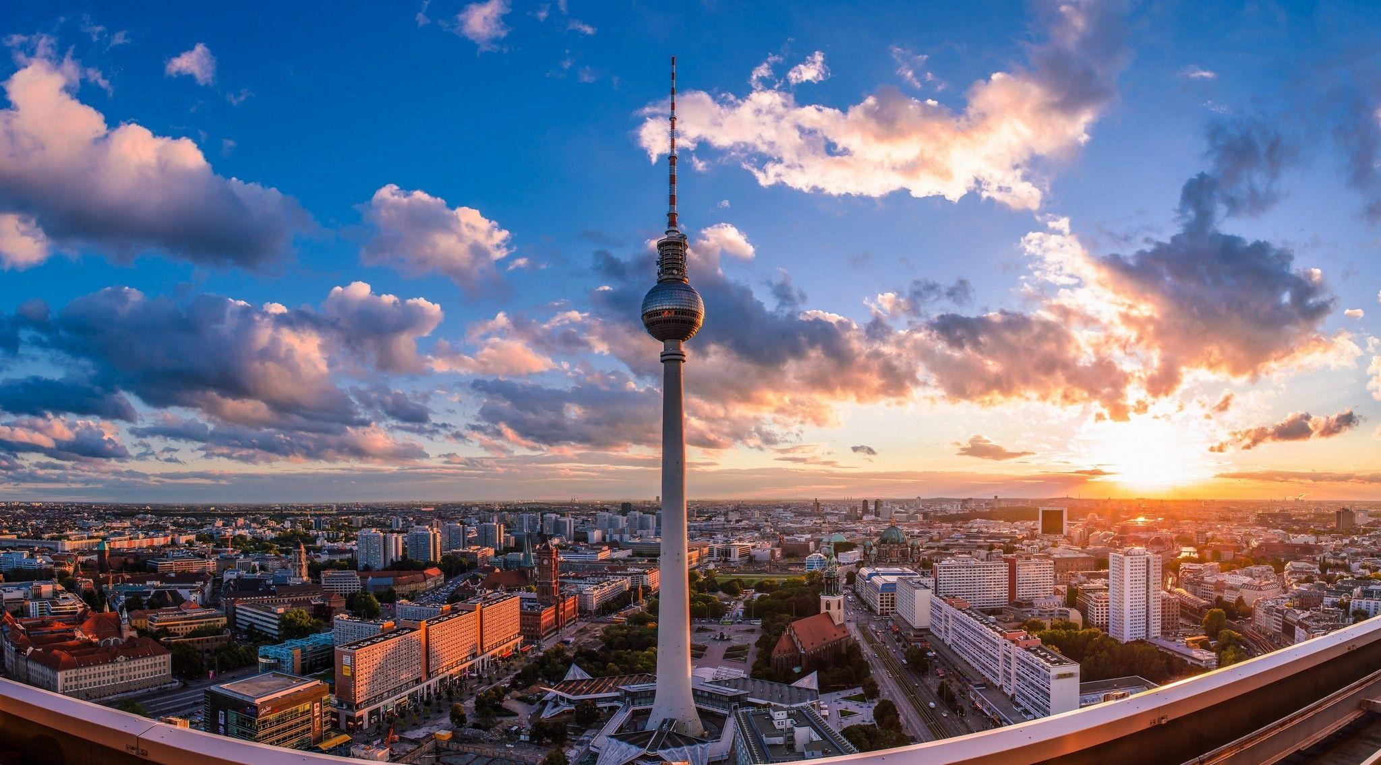

|  |  |  |
| --- | --- | --- |
| Feature | Basic Package | Premium Package |
| Hotel | 5-star | 5-star |
| Stay Duration | 7 days/nights | 10days/nights |
| Meals | Breakfast | Breakfast, Snacks |
| Tour Guide | No | Yes |
| Customer Service | 24/7 | 24/7 |
| Total Cost | €1500 | €2000 |

**Quick Links**

Home

Destination

Packages

Gallery

Contact

Book Now

**Contacts**

Phone: +36202600881

Email: [mailtoamir17@gmail.com](mailto:mailtoamir17@gmail.com)

Budapest, Attila út 125, 1012

Subscribe to our newsletter

**Odessey**  Amir Abdullah Zakaria All Rights reserved    

 **Odessey**

**Home Destination Packages Contact Book Now**

**Contacts**

**Our Services**

Explore our range of services tailored to make your travel experience unforgettable:

Personalized Itineraries

Seamless Booking Assistance

Expert Travel Advice

24/7 Customer Support

Contact Us

Have questions or need assistance? Reach out to us using the form below, or contact us directly:

**Contact Information:**

Phone: +36202600881

Email: [mailtoamir17@gmail.com](mailto:mailtoamir17@gmail.com)

Budapest, Attila út 125, 1012

Contact Form:

Name:

Email:

Phone Number:

Message:

Feel free to reach out to us via phone, email, or by filling out the form above. We're here to help make your travel dreams a reality.

**Quick Links**

Home

Destination

Packages

Gallery

Contact

Book Now

**Contacts**

Phone: +36202600881

Email: [mailtoamir17@gmail.com](mailto:mailtoamir17@gmail.com)

Budapest, Attila út 125, 1012

Subscribe to our newsletter

**Odessey**  Amir Abdullah Zakaria All Rights reserved    

 **Odessey**

**Home Destination Packages Contact Book Now**

**BOOK NOW**

Please fill out the form below to book your preferred package:

Name:

Email:

Phone no:

Destination:

Date:

No of person:

1 2 3 4 Others:

Package type: Basic Package

Premium Package

If you want any specific modification, write in the box below

I agree to the terms and conditions

subscribe for newsletter

**Quick Links**

Home

Destination

Packages

Gallery

Contact

Book Now

**Contacts**

Phone: +36202600881

Email: [mailtoamir17@gmail.com](mailto:mailtoamir17@gmail.com)

Budapest, Attila út 125, 1012

Subscribe to our newsletter

**Odessey**  Amir Abdullah Zakaria All Rights reserved    